Areas of learning
Our curriculum consists 17 areas of learning which are part of 7 Early learning goals.
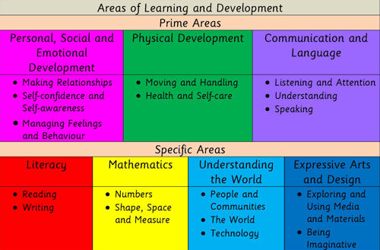

The prime areas are important because they lay the foundations for children’s success in all other areas of learning and in life.
The specific areas provide a range of experiences and opportunities for children to broaden their knowledge and skills.
Characteristics of effective learning
The Unique Child reaches out to relate to people and things through the Characteristics of Effective Learning, which move through all areas of learning.
• Playing and exploring
• Active learning
• Creating and thinking critically
Our practitioner’s interactions and our enabling
Environments allow our children
to develop in different ways.
For further information on the EYFS curriculum click
here: https://www.foundationyears.org.uk/
(Hyperlink ‘click here’)

