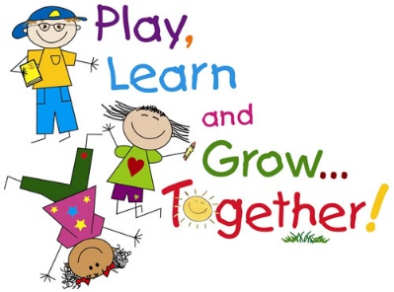
Iqra School
Parent Toddler Group
Are you a parent or Carer? Looking for something to engage your baby or toddler?
Pop along to the Iqra School Parent Toddler Group
Be part of a friendly, welcoming group every fortnight on a Monday during term-time 9.15-10.45am in the Iqra School Community Hall
Sessions will run on:
26th March, 23rd April, 14th May, 11th June, 25th June, 9th July 2018

Lots of fun activities; including lots of toys, arts and crafts, bouncy castle, book corner, story and song time.
Free entry, refreshments included. Just turn up or for more info call Salma Malik on 01753 520018 or Shaida on 07861261768

