Cross Curriculum: Science links
.Use of every day materials hot/ cold countries What are the main differences in climate for Africa and England?
Different materials used to build houses/huts.

Cross Curriculum: Music/Drama links
I can recreate African music .www.youtube.com/watch?v=fK0wPpLryc4
Learning Jambo song in Swahil Kenyan phrases – how to use and respond to foreign language.
YEAR 2 – Autumn Term Planning – Geography with Cross Curricular Links
Where would you prefer to live: England or Kenya?
Geography - Key text: Mama Panya’s Pancakes, Bringing the Rain to Kapiti Plain
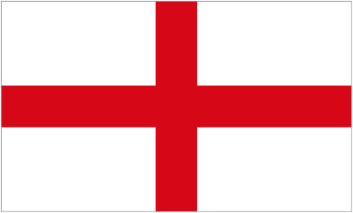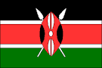
What would you ask……….?
What are African people proud of?
What are the main differences in the climate of Africa and England?
Which animals would you find living in the wild in Africa?
How can you create an Afrian mask?
Do Africans live a healthier life than we do?
What would your school day be like if you lived in African?

Educational visits / workshops:
African drumming workshop

Cross Curriculum: PSHE
Bullying and getting on and falling out
I know there are different types of bullying and teasing.
I know that bullying is wrong and know how to deal with bullying behaviours

Cross Curricular: Computing Links
NC Objectives:
I can use the internet to research information on Africa and compare the differences and similarities between England,
I know where to go for help if I am concerned.
I use technology respectfully.
SMSC:
To use the internet safely and respectfully by remembering the E-Safety rules.
To take turns using the laptops.

- Work successfully as a member of a group or team.

Cross Curricular: SMSC Links:
Cultural: An appreciation of the diversity and interdependence of cultures.
Moral: A willingness to express their views on ethical issues and personal values.
Social: Work successfully as a member of a group or team.

Cross Curriculum: Art / DT links
To create an African mask by using clay.
To be able to manipulate with clay by creating patterns using clay tools
SMSC- Share views and opinions with others, and work towards consensus.

British Values:

Tolerance – Looking at different cultures
Individual liberty – Children have the right to educations and freedom of choice,
Mutual respect – People having different faiths and beliefs

Cross Curricular: Maths Links:
Comparing the size of the two countries
Positioning countries on the world map
Cross Curricular: Writing Links:
To write a recount of a school day in Africa

