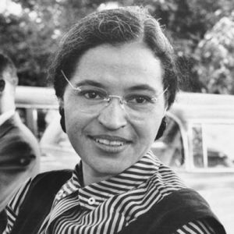 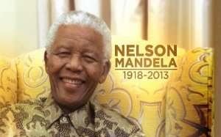

**Cross curricular: Media / Computing Links**

To act out in the role of Nelson Mandela and Rosa Parks by understanding how racism was challenged.

**SMSC:**

Social -To be able to work successfully as a member of a group or team.

**How have Rosa Parks and Nelson Mandela helped to make the world a better place?** History - Key text: The Skin I’m in (Pat Thomas), Cameroon can too Allie Brooke

**History NC Objectives**:

To research the life of a famous person from the past using different sources of evidence.

To answer questions using books and the internet.

To sequence events about the life of a famous person

To explain why a person in the past acted in the way they did

-To explain what is democracy and why it is a good thing.

**Educational visits / works**:

Diversity workshop to raise racial awareness and Inclusion

**British Values**

**Mutual Respect** –

Understanding of the importance of identifying and combating discrimination.

An acceptance that other people having different faiths or beliefs to oneself should be tolerated, and should not be the cause of prejudicial or discriminatory behaviour.

**YEAR 2 –Spring Term 1 Planning – HISTORY with Cross Curricular Links**

**Cross Curricular: Art Links**

**NC Objectives**

To create a portrait montage by using clipped shapes and repeated patterns that make a photo montage,

To suggest how artists have used pattern and shape

I can create a piece of art in response to the work of another artist.

**SMSC:**

To be able to comment on artist’s piece of work

An appreciation of the intangible

Awe and wonder

**Cross Curricular: Writing Links**

**NC Objectives**

To use past and present to write a recount of significant people.

I can write for different purposes, including real events.

I can use capital letters for names of people and places.

**SMSC:**

To respect and value other cultures

**Cross Curricular: SMSC Links**

Cultural -

An ability to appreciate cultural diversity and accord dignity to other people’s values and beliefs, thereby challenging racism and valuing race equality.

**To understand the importance of respecting all religions.**

Moral - An ability to distinguish right from wrong based on a knowledge of the moral codes and of their own and other cultures.

**Cross Curricular: Maths Links**

**NC Objectives**

To sequence a timeline of events

The sequence of historical events linked to understanding of number order.

To put a set of events into their correct historical sequence.

**SMSC**

A regard for the heights of human achievement in all cultures and societies.

**Cross Curricular: PSHE Links**

**NC Objectives**

What do you understand by the word discrimination?

To be able to identify positive and negative aspects about taking on a responsibility

Do you think children discriminate in any way?

Links with the charity Water Aid and UNICEF