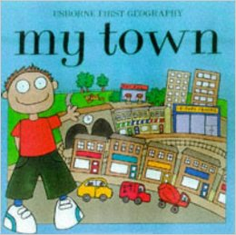 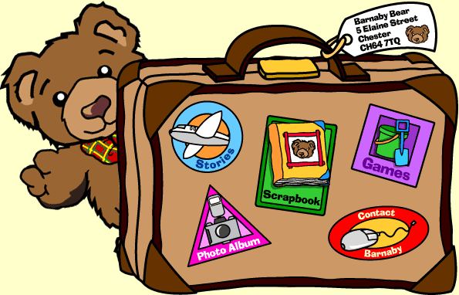 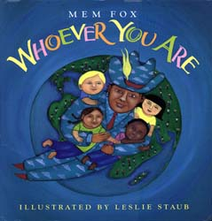

**Cross Curricular: Literacy Links**

Children will have to think of a number of questions they would ask Barnaby Bear if he appeared in their classroom.

Children make a comic book style 3D map of where Barnaby Bear visited in Slough

**NC Objectives**

I am able to orally rehearse structured sentences or sequences of sentences.

**Cross Curricular: Maths Links**

* Why would Barnaby Bear need to know my postcode to find my house?
* How would Barnaby Bear use his map to find his way to school?
* **NC Objectives**
* I can use mathematical vocabulary to describe position, direction and movement (including movement in a straight line and distinguishing between rotation as a turn and in terms of right angles for quarter, half and three-quarter turns (clockwise and anti-clockwise).

**What would Barnaby Bear find exciting about our town? (Key text: My Town and Whoever You Are**)

**Geography NC Objectives:**

* Where could I take Barnaby Bear on a special outing in our town?
* Why would Barnaby need to know my postcode to find my house?
* How would Barnaby use his map to find his way to school?
* What would appear on his map of our town?
* **Reflection: How could he use our town in one of his TV adventures?**

**Educational Visits / Workshops**

* **Local walk**
* **Trip to London Zoo**

**YEAR 2 – Spring Term 2 Planning – GEOGRAPHY with Cross Curricular Links**

**Cross Curricular: Science Links**

* Where could I take Barnaby Bear on a special outing in our town?
* To investigate a variety of plants and animals in our **local** habitat

**NC Objectives**

I can name some characteristics of an animal that helps it to live in a particular habitat.

**SMSC:**

Moral- To know how to respect plants and animals in our local habitat.

**Cross Curricular: SMSC Links**

Social: Understand how societies function and are organised in structures such as school and the local community.

Cultural: An appreciation of the diversity and interdependence of cultures.

**Cross Curricular: Computing Links:**

To use maps on the internet

Search Slough using Google maps and identfiy IQRA school.

**NC Objectives**:

To use technology purposefully to create,organise,store, manipulate and retrieve content.

**SMSC:**

How to use technology safely and respectfully by taking turns.

**Cross Curricular: PSHE Links**

Where could I take Barnaby Bear on a special outing in our town?

What would appear on Barnaby’s map of our town?

**NC Objectives:**

To show respect for all cultural and living things

**Cross Curricular: DT Links**

* Where could I take Barnaby Bear on a special outing in our town?
* **Children make a comic book style 3D map to show where Barnaby Bear visited in Slough**

**NC Objectives:**

* I can think of an idea and plan what to do next
* I can choose tools and materials and explain why I have chosen them
* I can join materials and components in different ways
* I can explain what went well with my work

**WOW: Children receive a visit from Barnaby Bear and take him on a trip around the local area.**

**British Values Link:**

Tolerance – learning to care for all regardless of their faith / culture.

Democracy – Learning about the roles and responsibilities of people who help us in the community