**Trip to Ruslip Lido**

**Cross Curricular: Computing Links**

**NC Objectives:**

To be able to design a postcard.

To create own digital postcards.

To use technology safely.

**SMSC:**

To use the internet safely and respectfully by remembering the E-Safety rules.

To take turns using the laptops.

**Cross Curricular: Art /DT Links**:

* Food Technology – What is picnic food?
* Food handling and hygiene
* To investigate what is picnic food – sandwiches and snacks
* Select from a wide range of ingredients to make picnic food

**SMSC:**

Citizenship: To be able to ask questions and share opinions what children are going to make.

**Why do we love to be beside the seaside?**

**Geography NC Objectives:**

* Where do you go on holiday and why?
* What attracts visitors to seaside resorts?
* What do you notice about the coast and how is it different to your town?
* What can we learn about lifeboats and lighthouses?
* What can you find in rock pools?
* What was Littlehampton like in the past?
* Reflection: Working with groups children will create a presentation on ‘What makes a seaside special?

**YEAR 2 – Summer Term 2 Planning – Geography with Cross Curricular Links**

[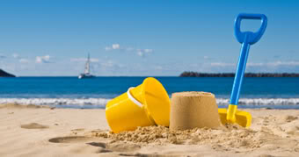](http://www.google.co.uk/url?sa=i&rct=j&q=&esrc=s&source=images&cd=&cad=rja&uact=8&ved=0CAcQjRw&url=http://www.ebay.co.uk/itm/SOUNDS-OF-THE-SEASIDE-CD-NATURAL-SOUNDS-CHILDHOOD-MEMORIES-THE-BEACH-/230796820635&ei=eFlYVY7HJse5UYTvgBA&bvm=bv.93564037,d.d24&psig=AFQjCNG1OCZaVLCqrQ-alb8_uby5u8msvw&ust=1431939802109731) 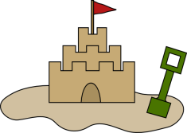

**Cross Curricular: Maths Links**

Carry out a research about their favourite holiday destinations and create graphs and charts.

Carry out research about their favourite sandwiches – bread/filling and record results in Venn diagram

**SMSC:**

Cultural: An appreciation of the diversity and interdependence of cultures.

**Cross Curricular: Science Links**

* What type of plants grow on the seaside?
* How is seaweed different from other plants?
* Do plants on the seaside need light, water and air?
* Natural / manmade materials on the beach
* **SMSC**:

To be able to explain the importance of looking after and respecting the seaside environment.

**Cross Curricular: Writing Links**

**NC Objectives:**

* Opportunities for descriptive writing- how the coast is different from your own town and to research postcard style writing.
* Nonfiction texts about the seaside in past and present.

**SMSC:**

Social: Taking turns and listening to others.

To respect and value each other’s opinions.

**Cross Curricular: Islamic Studies**

**The story of Prophet Yunus (as)**

**SMSC:**

* Spiritual:A respect for themselves and for others.
* Cultural: ability to recognise and understand their own cultural assumptions and values.

**Cross Curricular: PSHE Links**

E-Safety – To find a range of information from the internet.

Responsibility – of own actions

Economic well being

**Cross Curricular: SMSC**

Respecting the natural/ manmade features of the seaside.

Why is it important to follow rules when visiting the seaside?

An understanding of the dynamic nature of cultures (past and present)