**YEAR 3 – Spring Term 1 Planning – HISTORY with Cross Curricular Links**

**Cross Curriculum: Science/Geography:**

The relationship between human beings and the earth is increasingly complicated and urgent. Every day there are stories about pollution, global warming and animal species facing extinction.

Although human beings are seen as the most intelligent life form on earth, they are responsible for almost all the **damage** done to the planet. If we imagined the earth is aged 46, all the damage done has taken place in the last 60 seconds of the earth's life.

**NC Objectives:**

I can explain how an area has been spoilt or improved and give my reasons.

I can describe how some places are similar and dissimilar in relation to their human and physical features.

**Cross Curricular: Art:**

Looking at cave paintings and the stories behind them. Representing own story through cave painting style.

**Cross Curricular: Maths links:**

Ordering dates and sequencing them in order.

Money – Understand how coins were first made during the Iron Age.

**NC Objectives:**

Recognise value of each digit in a 3 or 4 digit number

Can compare and order numbers (dates)

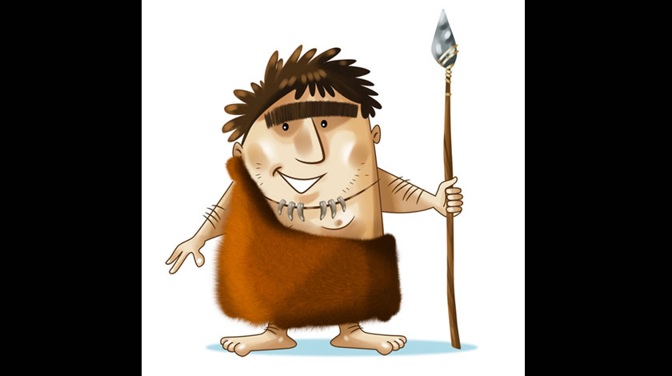

Science

**Who first lived in Britain –History NC Objectives:**

-Describe events and periods from the past using key dates and keywords.

-Use a timeline to order key events.

-Use their mathematical knowledge to work out how long ago events would have happened?

-Understand the work archaeologists carry out and the importance of it.

-Comparing their lifestyle to those living in ancient Britain

**Educational Visit:**

Celtic Harmony Camp.

**Cross Curricular: Writing - Explanatory texts:**

Creating a booklet, explaining the lifestyle of the ancient Britons.

**NC Objectives:**

I can produce non-narrative writing using simple organisational devices such as headings and sub-headings. I can organise writing into paragraphs.

**Cross Curricular: DT:**

Designing and making models of Celtic monasteries.

**NC Objectives:**

I can prove that my design meets some set criteria.

I can design a product and make sure that it looks attractive

I can select the most appropriate tools and techniques for a given task.

**Cross Curricular: PSHE Links:** listen to and show respect for the views of others

Identify positive ways to face new challenges

I know that choices we make can impact on the local and global communities

**SMSC Links:**

**Social –** Show respect for people, living things, property and the environment.

Exercise responsibility.

**Spiritual –** An appreciation of the intangible – for example, beauty, truth, love, goodness, order, as well as for mystery, paradox and ambiguity.

Cultural - An understanding of the influences that have shaped their own cultural heritage.

A regard for the heights of human achievement in all cultures and societies.

An ability to use language and understand images/icons, for example in music, art and literature which have significance and meaning in culture.

**Cross Curricular: Computing Links:**

* Use search engines to research about Stone, Iron and Bronze age
* Present information in the form of a presentation to present to an audience. (Homework link)

**NC Objectives:**

Use search technologies effectively

Use technology safely, respectfully and responsibly.