**Cross Curriculum: PSHE Links:** Understanding of British Values - Democracy and rights and responsibilities. As a British citizen what rights are we given? How do we as a school follow a democratic system? What different responsibilities do pupils have within school?

-Participate in making and changing rules.

-Know why different rules are needed in different situations.

-Know that choices we make can impact on the local and global communities.

-Know where to find impartial advice to inform my decision making.

**YEAR 3 – Spring Term 2 Planning – HISTORY with Cross Curricular Links**

**Cross Curriculum: Art and design/ Design and Technology Links:**

Designing and making a clay pot using techniques such as coiling.

**NC Objectives:**

Art:

I recognise when art is from different cultures.

I recognise when art is from different historical periods.

DT:

I can design a product and make sure that it looks attractive.

I can select the most appropriate tools and techniques for a given task.

**Educational visit:**

Visit British Museum to get inspirational ideas from existing Greek vases.

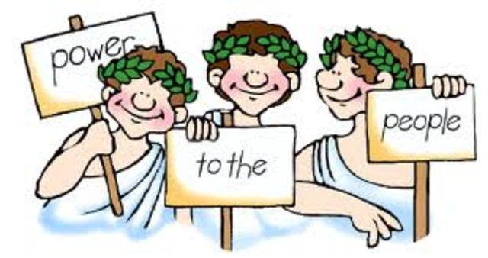

***Why were the Greeks so Groovy?***

***History NC Objectives***

* Describe events and periods from the past using key dates and keywords.
* Use a timeline to order key events.
* Understand what democracy is and what part the Greeks had in creating it.
* Research a specific event from the past
* Suggest why certain events happened the way they did in history.

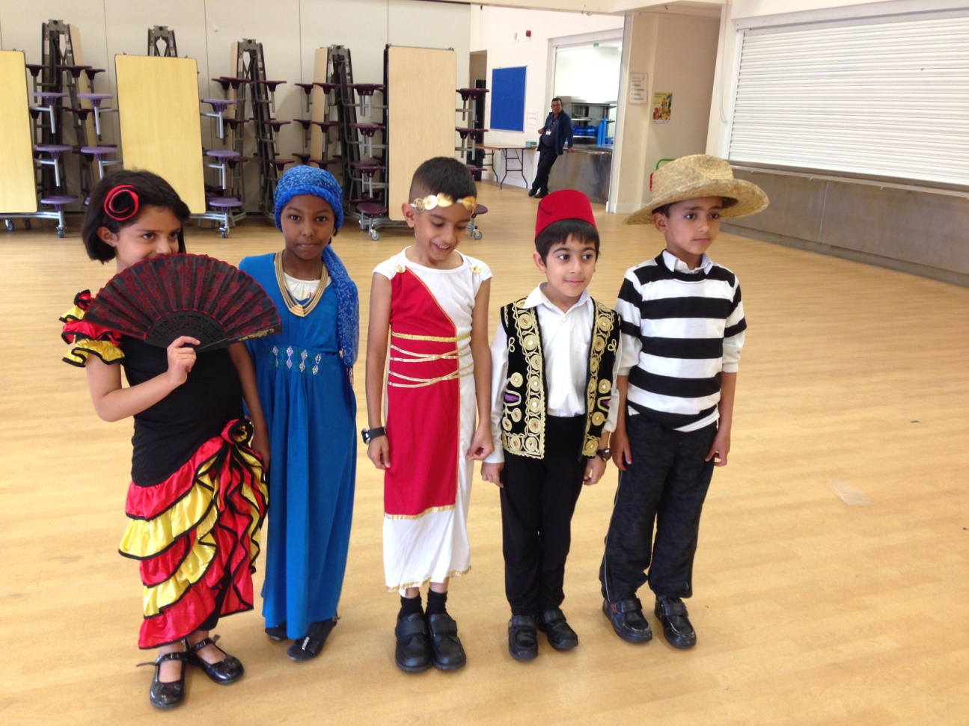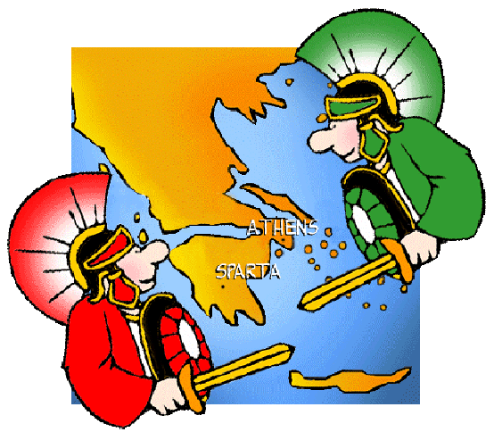

**Individual liberty:**

Freedom to express their own cultures.

Tolerance s of

Able to tolerate other cultures apart from their own

Able to tolerate other cultures apart from their own

**Cross Curriculum: SMSC Links:**

**Cultural -** An understanding of the influences that have shaped their own cultural heritage.

**Morals -** An understanding of the need to review and re-assess their values, codes and principles in light of experience.

**Social:** Appreciate the rights and responsibilities of individuals within the wider social setting.

Understand how societies function and are organised in structures such as the family, the school and local and wider communities.

**Social -** A set of values, principles and beliefs, which may or may not be religious, which inform their perspective on life and their patterns of behaviour.

**Cross Curriculum: Computing Links:**

* Use search engines to research about the Greeks
* Carry out surveys and present data in the form of charts/ graphs

**NC objectives:**

Use search technologies effectively

Use technology safely, respectfully and responsibly.

**Cross Curriculum: Writing/ Reading Links:**

Use reading skill, finding information, to write about historical information.

**NC objectives:**

I can identify the main point of a text.

I can ask relevant questions to get a better understanding of a text.

**Cross Curriculum: Geography links:**

Use world map to identify countries/ oceans and seas

**NC objectives:**

Use world map to identify countries, continents and oceans.

**SMSC Links:**

Allah’s beautiful creation – the earth

**Cross Curriculum: Maths links:**

Ordering dates and sequencing them in order.

Present data in the form of charts/ graphs

**NC objectives:**

Recognise value of each digit in a 3 or 4 digit number

Can compare and order numbers (dates)