**YEAR 3 – Summer Term 1 Planning –Geography with Cross Curricular Links**

**Cross Curricular: Writing**

Children to write a discussion text whether it’s better to live in Slough or London

**NC objectives:**

I can produce non-narrative writing using simple organisational devices such as headings and sub-headings.

I can suggest improvements to my own writing and that of others.

I can make improvements to grammar, vocabulary and punctuation

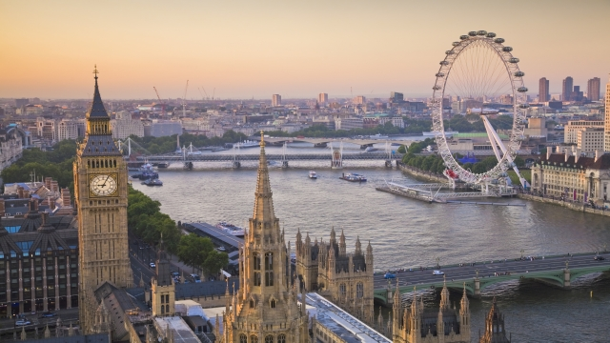

**Cross Curricular: Reading**

Children will be reading non- fiction texts on the River Thames to understand why it is so important.

**NC objectives:**

I can explain how structure and presentation contribute to the meaning of texts.

I can use non-fiction texts to retrieve information.

I can ask relevant questions to get a better understanding of a text.

**Why is the River Thames so important?**

*NC Geography Objectives****:***

I can name and locate the capital cities of neighbouring European countries.

I can name a number of countries in the northern hemisphere.

I can use an atlas by using the index to find places.

I can use grid references on a map.

I can use some basic Ordnance Survey map symbols.

NC History Objectives***:***

I can use research skills to find answers to specific historical questions.

I can research in order to find similarities and differences between two or more periods of history.

**Educational visit:**

Henley

**Cross Curricular: PSHE**

I can show respect for nature and understand how actions can have an effect on others e.g. pollution

I can empathise with others on topical and cultural problems and events – How might people feel if they didn’t have access to water?

What happens when areas are flooded?

I can appreciate the finances involved in maintaining the Thames Barrier

I know that choices we make affect us globally.

**Art and design**

Water colours – children will be studying the work of Bridget Riley.

**NC Objectives:**

I can create a background using a wash.

I can use a range of brushes to create different effects in painting.

I can identify the techniques used by different artists

I can compare the work of different artists.

v

**British Values Link:**

**Mutual respect –**

Understand how we should respect nature and not destroy it (pollution)

Understand the importance of rivers in different countries.

**Maths links:**

**NC objectives:**

I can interpret and present data using bar charts, pictograms and tables.

I can compare lengths using m, cm &mm.

**Computing:**

Use search engines to research about rivers around the world

Carry out surveys and present data in the form of charts/ graphs

**NC objectives:**

Use search technologies effectively

Use technology safely, respectfully and responsibly.

*http://www.dovesfarm.co.uk/recipes/roman-army-bread*

**Cross Curricular: SMSC Links:**

**Moral:** Is it right that people drop litter into rivers?

How does this effect fish/ducks?

**Social:** How do rivers contribute to the community?

**Cultural:** The importance of water in other countries.

**Spiritual:** Understanding the impact of rivers on the community.