**YEAR 4 – Spring Term 1 Planning – Geography with Cross Curricular Links**

**Cross Curricular: Writing**

Children to create their own tourist leaflet, persuading tourists to visit London attractions.

**NC objectives:**

In non-narrative material, using simple organisational devices (for example, headings and subheadings)

I can write clearly, accurately and coherently, adapting my language and style in and for a range of contexts, purposes and audiences.

I can improve my writing by changing grammar and vocabulary to improve consistency.

**Cross Curricular: Reading**

Children will be exploring non-fiction texts such as information texts, letters and biographies to increase their general knowledge.

**NC objectives:**

I know which books to select for specific purposes, especially in relation to science, geography and history learning.

I can explain the meaning of words in context.

I can retrieve information from non-fiction texts.

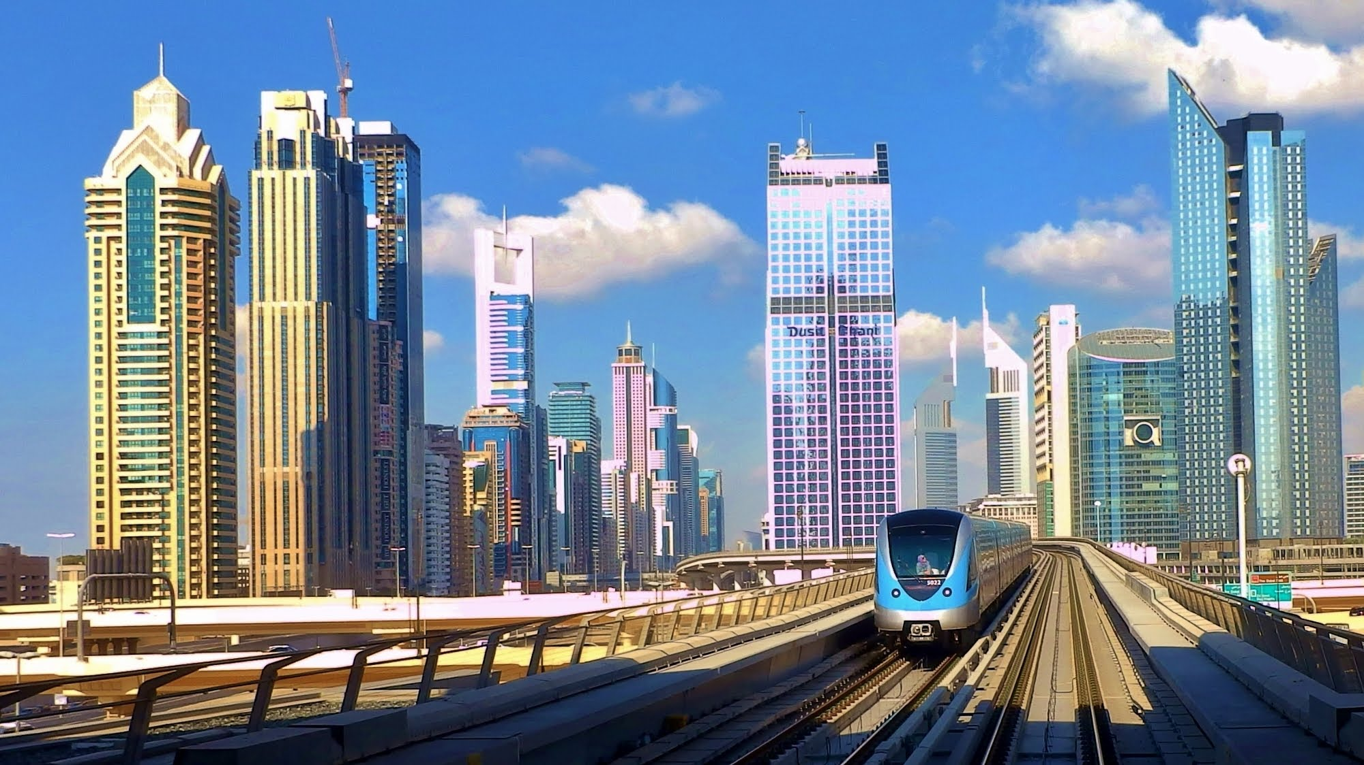

**Why is London a cool place to live?**

* **Geography NC Objectives:**
* *To understand the advantages and disadvantage of living in London.*
* *Exploring London transport and how it can be helpful but also how it affects the environment.*
* *I can carry out research to discover key attraction in London.*
* *I can explain why people may choose to live in one place rather than another.*

**Cross Curricular: DT/Art**

Children will construct a sustainable/durable structure that can stand independently using a range of raw materials.

**NC objectives:**

I can use ideas from other people when I am designing.

I can produce a plan and explain it.

I can evaluate and suggest improvements for my designs.

I can explain how I have improved my original design.

**Cross Curricular: PSHE**

I know what diversity is.

I understand how we need to respect individual choice

I can explain how there is diversity within the Muslim community and how that is acceptable.

I understand how the Prophet Muhammad (saw) showed tolerance to those different to himself.

v

**Cross Curricular: Maths**

Children will be working with money in the context of decimals, percentages and fractions.

**NC objectives:**

I can count up and down in hundredths

I can compare numbers with the same number of decimal places up to two decimal places

I can recognise equivalent fractions

recognise and write decimal equivalents of any number of tenths or hundredths

I can add and subtract fractions with the same denominator

I can solve problems involving increasingly harder fractions.

**British Values Link:**

**Democracy / Individual liberty:**

Children understand the importance of recycling and discuss how to recycle and reuse everyday items to protect the environment. Children discuss how they could make sensible choices to create a clean environment.

**Cross Curricular: SMSC Links:**

**Moral:** A respect for others’ needs, interests and feelings, as well as their own.

**Social:** Relate well to other people’s social skills and personal qualities.

**Cultural:** A willingness to participate in, and respond to, artistic and cultural enterprises.

**Spiritual:** An expressive and/or creative impulse.