**Cross curricular link: Art and Design.**

Pupils to design and build their own kites ( a popular toy in Edwardian times).

I can measure accurately.

I can persevere and adapt my work when my original ideas do not work.

I can produce a plan and explain it.

I can evaluate and suggest improvements for my designs.

**Cross curricular link: Writing**

Children to write a diary entry of from the perspective of a child living in the UK circa 1915.

**NC Objectives:**

I can write in paragraphs.

I can improve my writing by changing grammar and vocabulary to improve consistency.

I can use noun phrases which are expanded by adding modifying adjectives, nouns and preposition phrases.

I can compose sentences using a range of sentence structures.

**Year 4 Curriculum MTP – History Spring 2**

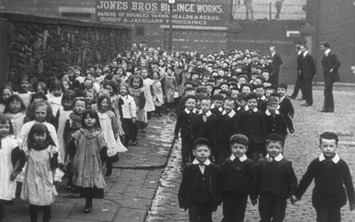

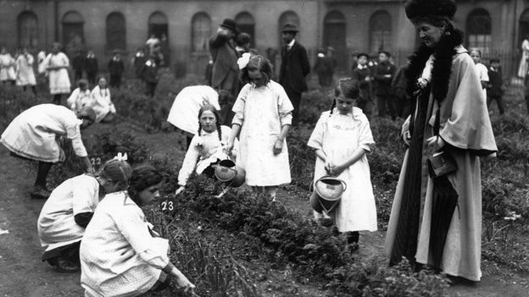

**Cross curricular link: Maths**

Chln to use different skills for DT and present data on favourite pass times.

I can calculate different measures

I can identify lines of symmetry in 2D shapes presented in different orientations.

I can identify acute and obtuse angles and compare and order angles up to two right angles by size.

I can interpret and present discrete and continuous data using appropriate graphical methods, including bar charts and time graphs.

**What would you have done after school 100 years ago?**

**History NC Objectives:**

* I can explain how historic items and artefacts can be used to help build up a picture of life in the past.
* I can explain how an event from the past has shaped our life today.
* I can research what it was like for children in a given period of history and present my findings to an audience.

**Cross curricular link: PSHE**

I can respond appropriately to other people’s feelings.

I can take responsibility for my own behaviour and safety and realise that actions have consequences.

I can describe some of the different beliefs and values in society, and demonstrate respect and tolerance towards people different from themselves.

I can recognise the worth of other people.

Cross curricular- SMSC Links

Social: Appreciate the rights and responsibilities of individuals within the wider social setting.

Cultural: An understanding of the influences that have shaped their own cultural heritage.

Morals: An ability to make responsible and reasoned judgements on moral dilemmas.

Spiritual: A respect for themselves and for others

**ICT usage:**

Extensive use BBC primary WW1 resources to engage children. Pupils to use Microsoft PowerPoint to catalogue their learning from Topic in ICT lessons. This will develop a variety of transferable ICT skills. These skills include;

* copying and pasting, Typing, changing size and colour of Font,
* Changing colour of text boxes,
* Finding and selecting specific programs, Navigating sites from internet explorer.

At the end of term pupils will use their work and present to rest of class.

Cross curricular- SMSC Links

Social: Reflect on their own contribution to society and to the world of work.

Cultural: An ability to use language and understand images/icons, for example in music, art and literature which have significance and meaning in culture.

Morals: A desire to explore their own and others’ views.

Spiritual: Developing a climate or ethos within which all students can grow and flourish, respect others and be respected.