**YEAR 5 – Autumn Term 1 Planning – GEOGRAPHY with Cross Curricular Links**

[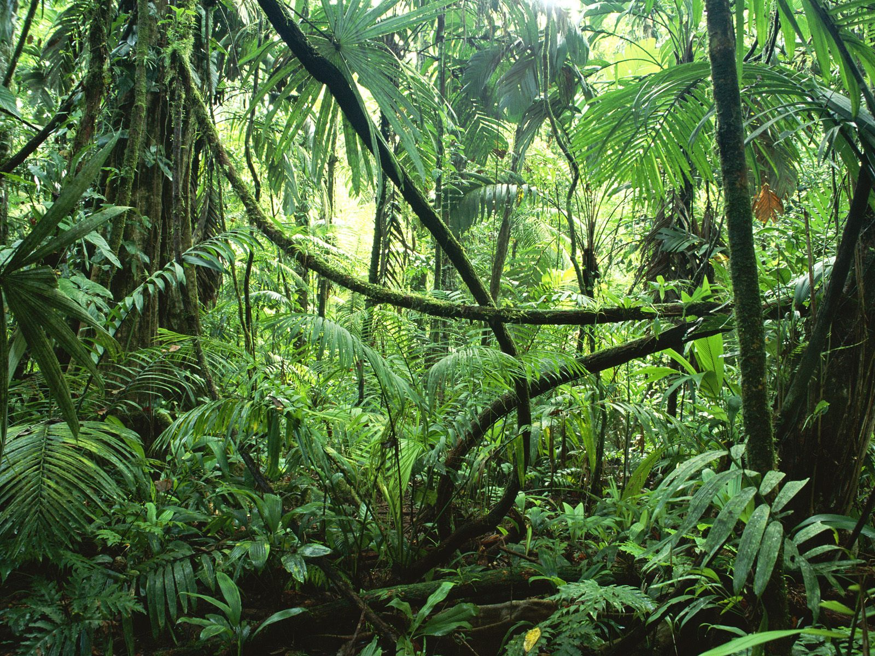](http://www.google.co.uk/url?sa=i&rct=j&q=&esrc=s&source=images&cd=&cad=rja&uact=8&ved=0CAcQjRxqFQoTCPTIl6z168YCFcmZ2wodEJsAZg&url=http://www.theschoolrun.com/homework-help/rainforest-habitats&ei=shGuVfSnDsmz7gaQtoKwBg&bvm=bv.98197061,d.d24&psig=AFQjCNEBgLV-xZ_xxW3SomjyyIV8VaoZJA&ust=1437557426987769)

**Cross Curricular: Writing Links:**

Create a leaflet using the research gathered about an endangered animal.

**NC Objectives:**

I can discuss the audience and purpose of the writing.

I can organise my writing into paragraphs to show different information or events.

I can add well-chosen detail to interest the reader.

**Cross Curricular: Art and Design Links:**

Students will research the work of Henri Rousseau. They will be creating their own prints using large leaves of rainforests

**NC Objectives:**

To create an accurate print design following criteria.

To research the work of an artist and use their work to replicate a style.

**Cross Curricular: Maths Links:**

Students will be looking at symmetry within leaves. They will create their own symmetrical leaf prints.

**NC Objectives:**

To identify, describe and represent the position of a shape following a reflection or translation, using the appropriate language, and know that the shape has not changed.

***Why should the rainforest be important to all of us?***

**Geography NC Objectives**

* To understand where rainforests are located and what are their main features
* Understand how important the Amazon is to the South American Rainforest
* Discuss why rainforests are often in the news and how we can help them
* Research about an endangered animal that lives in the rainforest (Homework)
* To create a print using the large leaves of rainforests.

**Trips – visit to the Living Rainforest London**

**Cross Curricular: PSHE Links**

Discuss the issue around deforestation and how removing rainforests will impact many habitats.

**SMSC Link:**

**Spiritual:**

* A respect for themselves and for others.

**Social:**

* Show respect for people, living things, property and the environment.

Appreciate the rights and responsibilities of individuals within the wider social setting

**Cross Curricular: Computing Links:**

Students will research an endangered animal for homework.

**NC Objectives:**

To competently use the internet as a search tool.

I can reference information sources.

**Cross Curricular: SMSC Links**

**Moral:**

* An ability to think through the consequences of their own and others actions.
* A willingness to express their views on ethical issues and personal values.

**Spiritual:**

* A sense of empathy with others, concern and compassion.
* Developing a climate or ethos within which all students can grow and flourish, respect others and be respected.

**Cross Curricular: Media Links:**

To report on geographical facts through a journalistic approach in the style of a documentary

To improve their social and emotional skills through role play and empathy towards geographical issues

To build upon their self-evaluation and self-reflection skills through editing their own and each other’s work.

**NC Speaking k& listening Objectives:**

Use relevant strategies to build their vocabulary

Speak audibly and fluently with an increasing command of Standard English

**British Values Link:**

**Individual liberty** – expression their personal views during discussion on deforestation and its impact on the wider world.

**Mutual respect** – respecting different localities and understanding the need to protect rainforests.