**Cross Curricular: D.T Links:**

**Clay modelling:** Pupils to explore Egyptian dress in particular the use of jewellery used to show wealth. Children to use clay to create Armlet’s.

**Art:** Pupils to create their own Cartouche paintings using the Egyptian alphabet. They will have the opportunity to familiarise themselves with symbols used by the Egyptians and create them using paint.

**NC Objectives:**

* *Develop skills in using clay*
* *Develop different ideas which can be used and explain his/her choices for techniques used*
* *Confidently and systematically investigate the potential of new and unfamiliar materials and use these learnt techniques within his/her work*
* *Evaluate his/her work against their intended outcome*

**YEAR 5 – Spring Term 2 Planning – History with Cross Curricular Links**

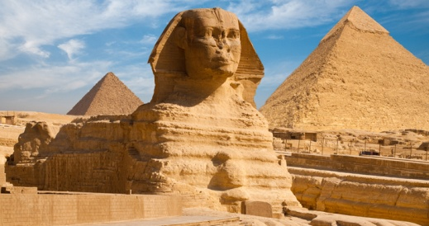

**Cross Curricular: Computing Links – We are architects!**

Pupils will be designing their own pyramids structures using a simple CAD tool, developing spatial awareness by exploring and experimenting with a 3D virtual environment.

**NC Objectives:**

Understand the work of architects, designers and engineers working in 3D.

Use technology safely, respectfully and responsibly;

**How can we rediscover the wonders of Ancient Egypt?**

**History NC Objectives:**

* *Use dates to order and place events on a timeline*
* *Compare sources of information available for study of different times in the past*
* *Make comparisons between aspects of periods of history and the present day*
* *Understand that the type of information available depends on the period of time studied*
* *Evaluate the usefulness of a variety of sources*

**Art workshop: Hieroglyphics**

Pupils will make their own Cartouche paintings with a professional external agency.

**Cross Curricular: Maths Links**

-Using mathematical skills to chronologically order dates.

**NC Objectives:**

-Recognise value of each digit in a 3 or 4-digit number

-Can compare and order numbers

-Work out time intervals between BC and AD in history

**Cross Curricular: Reading Links**

Looking at Egyptian attire and comparing it to British attire.

**NC Objectives:**

-To make comparisons within a text

-Checking that the text makes sense to them, discussing their understanding and exploring the meaning of words in context

-Drawing inferences and justifying with evidence

**Cross Curricular: SMSC Links:**

Cultural: Have an understanding of the influences that have shaped their own cultural heritage.

Spiritual: An awareness and understanding of their own and others beliefs - Explore the beliefs of afterlife in Ancient Egypt, comparing the preparation of death and use of wealth to good deeds in Islam.

Abu Hurairah narrated that Prophet Muhammad (peace be upon him) said,*"****When a man dies, his good deeds come to an end except three: ongoing charity, beneficial knowledge, and righteous offspring who will pray for him.****"*

**Cross Curricular: Science Links:**

Conducting an experiment to understand how the ancient Egyptians moved the huge stone blocks which were used to make the pyramids. Also learn how weight was dispersed by using different stone.

**NC objectives:**

-To identify the effects of friction that act between moving surfaces

-To recognise that some mechanisms, including levers, pulleys and gears, allow a smaller force to have a greater effect.

**British Values Link:**

Individual Liberty - To know and show mutual respect towards different viewpoints

Tolerance of those with different faith - Explore different countries and eras in history, learn about the culture, religions, and traditions in history and current events and situations today allowing children to be more tolerant and respectful.

**Cross Curricular: Writing Links**

Writing a diary entry from an archaeologist’s point of view. <https://www.literacyshed.com/the-egyptian-pyramids.html> link to video clips.

**N.C Objectives:**

-To identify the audience for and purpose of the writing

-To select appropriate grammar and vocabulary, understanding how such choices can change and enhance meaning