**Cross Curricular: Art and Design Links:**

**Anglo-Saxon art focusing on tessellations?**

Children will create their own Anglo Saxon tessellation.

**NC Objectives:**

I can create an accurate pint design following criteria

I can use images that I have created, scanned and found; altering them where necessary to create art.

**YEAR 5 – Summer 1. Were the Anglo Saxons really smashing?**

[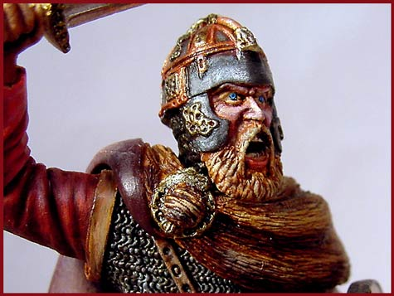](http://www.google.co.uk/url?q=http://www.nbcnews.com/slideshow/today/brazils-carnival-celebrations-50736176&sa=U&ei=DHK2U8_LGYH_PPbFgcAK&ved=0CDwQ9QEwEw&usg=AFQjCNEmPyjhvbVeqw_u4Moc7U8eP0_bJw)

**Cross Curricular: Writing Links:**

Children to write a non-chronological report about the different types of law and order making comparisons with today.

**NC Objectives:**

Expected:

* I can use the correct features and sentence structure to match the text type we are working on.
* I can organise my work into paragraphs to show different information.

Exceeding:

* I can use paragraphs to organise work logically and shape a non-fiction text effectively.

**Cross Curricular: Maths Links:**

Measure correctly to identify line of symmetry and complete designs. Use knowledge of shape to create a tessellation. Children will also be comparing the duration of different events in history using the Anglo Saxons timeline.

**Who were the Anglo-Saxons and how did they influence our lives today?**

Who were the Anglo-Saxons? Where did they settle?

Why did they invade? What time period is this from? Who were the leaders?

**Geography NC Objectives**

* I can draw a timeline with different historical periods. Explaining things which changed and things which stayed the same.
* I can explain how our locality has changed over time.

**Trips – Workshop (TBC)**

Learn about the way of life of the Anglo Saxons

**Cross Curricular: SMSC Links**

Do the British way of life resemble any of those from the Anglo Saxons?

How did the Anglo Saxons influence the British and their way of life today?

* An understanding of the influences that have shaped their own cultural heritage
* A set of values, principles and beliefs, which may or may not be religious, which inform their perspective on life and their patterns of behaviour.

**Cross Curricular: Computing Links:**

**Use**

Creating tessellation - this will be combined with using coding and robotics from our ICT curriculum. Children will use scratch the produce a tessellation pattern inspired by the Anglo-Saxons.

**Cross Curricular: PSHE links**

I can identify the range of jobs carried out by people – Children will be looking at the jobs carried out by the Anglo Saxons and comparing them to the jobs today.

I understand that circumstances in other countries and cultures may be different from our own – Children will be comparing the way of life of the Anglo Saxons in History to our way of life today. Reinforcing the differences in childhood.