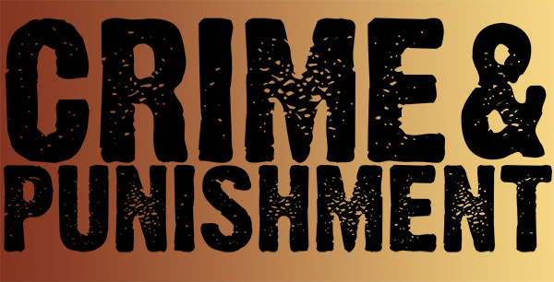

**Cross Curricular: D.T Links:**

**Clay modelling:** Children to explore Anglo-Saxon jewellery and to create these in clay

**Food and Design:** Children to explore traditional Anglo-Saxon food and the heritage. Children to taste and recreate simple dishes.

**NC Objectives:**

-Develop design criteria to inform the design of innovative, functional, appealing products that are fit for purpose, aimed at particular individuals or groups

-Select from and use a wider range of tools and equipment to perform practical tasks

-Select from and use a wider range of ingredients/materials, according to their functional properties and aesthetic qualities

-Evaluate their products against the design criteria and consider the views of others to improve their work

**YEAR 5 – Summer 1 – History with Cross Curricular Links**

**Cross Curricular: Computing Links – We are artists!**

Children will be designing their own jewellery or shield using Inkscape.

**NC Objectives:**

Understand the work of architects, designers and engineers.

Use technology safely, respectfully and responsibly

**Crime and Punishment 1066-1700**

**History NC Objectives:**

* I can draw a timeline with different historical periods showing key historical events or lives of significant people.
* I can compare two or more historical periods; explaining things which changed and things which stayed the same.
* I can make comparisons between historical periods time present.
* I understand the history of crime and punishment

**Cross Curricular: Reading Links**

Looking at a range of texts linked to Oliver Cromwell.

**NC Objectives:**

-To make comparisons within a text

-Checking that the text makes sense to them, discussing their understanding and exploring the meaning of words in context

-Drawing inferences and justifying with evidence

**Cross Curricular: Maths Links**

-Using mathematical skills to chronologically order dates.

- interpret data to draw conclusions

**NC Objectives:**

-Can compare and order numbers

-Work out time intervals between BC and AD in history

-draw conclusions from interrupting data

**Cross Curriculum: RE**

Understanding of the key religion of the time and how religion supports families and communities.

**NC Objectives:**

**-**Describe the impact of beliefs and practices on individuals, groups and communities

**Cross Curricular: SMSC Links:**

Cultural: Have an understanding of the influences that have shaped their own cultural heritage.

Spiritual: An awareness and understanding of their own and others beliefs - Explore the beliefs of the time and comparing how values and opinions have changed over time

**Cross Curricular: Writing Links**

.Diary writing based on the changes over time linked to the theme

-report writing on Oliver Cromwell

**N.C Objectives:**

-To identify the audience for and purpose of the writing

-To select appropriate grammar and vocabulary, understanding how such choices can change and enhance meaning

**British Values Link:**

Individual Liberty - To know and show mutual respect towards different viewpoints

Tolerance of those with different faith - Explore different countries and eras in history, learn about the culture, religions, and traditions in history and current events and situations today allowing children to be more tolerant and respectful.