**CURRICULUM NEWSLETTER**

**YEAR 6**

**AUTUMN TERM 2017**

Dear Parents / Carers,

Please find below the units that your child will be learning this term.

**English**

**Writing:**

*Text types: Narrative, Procedural and Non Chronological Reports.*

* To be able to identify the audience and purpose of the writing.
* To be able to use a range of sentence starters to create specific effects.
* To be able to sustain and develop ideas logically in fictional and non-fictional narrative writing.
* To select vocabulary and grammatical structures that reflect the level of formality required.

**Reading:**

*Focus texts: Street Child and Kensuke’s Kingdom*

* To be able to read books that are structured in different ways.
* To be able to identify themes in texts.
* To be able to identify and explain how writers use grammatical features for effect.
* To express a personal point of view about a text, giving reasons linked to evidence from texts.

**Grammar:**

* To use a range of cohesive devices including adverbials, within and across sentences and paragraphs.
* To use passive and modal verbs mostly appropriately
* To use a wide range of clause structures, sometimes varying their position

**Maths**

* To be able to read, write, order and compare numbers up to 10,000,000
* To determine the value of each digit in numbers up to 10,000,000.
* To be able to round any whole number to a required degree of accuracy.
* To use negative numbers in context, and calculate intervals across zero.
* To solve problems involving addition, subtraction, multiplication and division.
* To identify common factors, common multiples and prime numbers.
* To be able to perform mental calculations, including with mixed operations and large numbers.

**Arabic Studies**

**Weather & holidays:**

Autumn term in year 6 will include the topics weather & holidays. While many students may have covered the subject on a very basic level, the aim now is to enable students to give extended answers to questions and have deeper conversations. Students will also learn how to use the 5 singular forms of the personal pronoun and revise rules on gender with Arabic nouns. The second half of the term will involve talking about how to have a conversation that involves regarding holidays. This will involve students enhancing the use of adjectives in Arabic, as well as learning currencies and metric measurements. The term will end with a short assessment.

**Science**

In Science pupils will be covering the topics “Living things and their habitats” and “The human circulatory system”. During these topics, children will explore living things including microorganisms, plants and animals. They will deepen their understanding of the functions of the heart, blood vessels and blood. Through their enquiry skills they will explore the effects of exercise on the heart and pulse rate.

**PE**

In PE this term, children will be taking part in Handball and Basketball.

**RE**

**Key Beliefs:**

The children will explore the articles of faith. They will focus on how all good and bad is from Allah. They will understand how Allah has a better plan for us.

**Additional Information**

**Preparation:**

All children should have the school PE kit as this is part of their uniform. This **must** include trainers or plimsolls. Children are not allowed to do PE in their school shoes. PE kits need to be bought in on Monday and remain in school on their peg for the week.

Please ensure that children are prepared for school every day. Children are expected and should be encouraged to attend every lesson with a pencil case and all necessary stationary.

**Homework:**

Homework will continue to be given out on a Friday for it to be completed by the following Tuesday. In addition to this, Year 6 children are expected to read independently for at least 20 minutes on a daily basis. Please encourage your child to set time everyday to complete the homework that they are set.

We hope that you find this information useful and will continue to support your child’s learning at home.

Yours faithfully,

Mrs Ansari (Year Leader) Mrs Munir, Mrs Khan, Miss Dhillo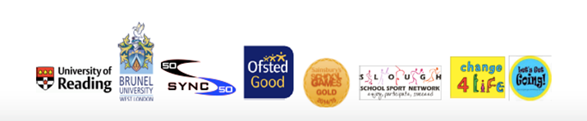n