**YEAR 2 – Term 1 Planning –Great Fire of London(History)**

**Cross Curricular: Writing: Charlie and the Fire of London**

* Character description of a roman soldier
* Narrative – short story
* Instructions – how to make a Roman shield

**NC Objectives:**

* To write sentences that are linked thematically eg personal experiences and those of others (real and fictional)
* Write for different purposes to develop positive attitudes and stamina for writing
* Consider what he/she is going to write before beginning by writing down ideas and /or key words, including new vocabulary
* Start to use the diagonal and horizontal strokes needed to join letters

**Cross Curricular: Computing** **Links**

To recognise common uses of information technology beyond school

**NC Objectives:**

* To create simple programs
* Use technology purposefully to create, organise, store, manipulate and retrieve digital content

**Cross Curricular: Reading:**

Develop phonic knowledge, structure and vocabulary.

**NC Objectives:**

* Continue to apply phonic knowledge and skills as the route to decode words until automatic decoding has embedded and readings fluent
* Read common exception words, noting unusual correspondences between spelling and sound and where these occur in the word
* Develop pleasure in reading, motivation to read, vocabulary and understanding by discussing the sequence of events in books and how items of information are related

**History NC Objectives:**

- To show an awareness of the past, using common words and phrases relating to the passing of time

- to show an understanding of some of the ways we find out about the past and identify different ways in which it is represented (looking at Samuel Pepys diary)

**Educational visit:**

- Great fire of London drama workshop

- British Museum

**Cross Curricular: Art/DT**

Recreating art work using inspiration from Fire of London

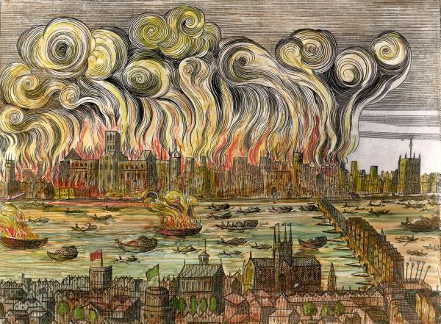

**NC Objectives:**

* To be able to select particular techniques to create a chosen product and develop some care and control over materials and their use
* Experiment with tones using pencils, chalk or charcoal

**Cross curricular: Science- Materials**

To ask simple questions and recognise that they can be answered in different ways including using scientific language

To identify, group and classify

Describe how the shapes of solid objects made from some materials can be changed by squashing, bending, twisting and streching

**Cross Curricular: SMSC**

* Work successfully as a member of a group or team.
* Share views and opinions with others, and work towards consensus.
* An understanding of the influences that have shaped their own cultural heritage.
* Show respect for people, living things, property and the environment.
* Helping students develop personal qualities which are valued in a civilised society - for example, thoughtfulness, honesty, respect for difference, moral principles, independence, interdependence, self-respect.