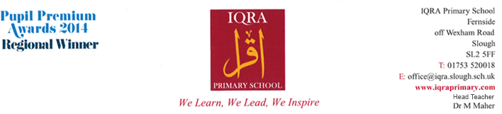
CURRICULUM NEWSLETTER
YEAR 2
AUTUMN TERM 2018

Dear Parents / Carers,
Please find below the units that your child will be learning this term.
Writing

- Non Fiction – Instructions and Explanation texts
- Narrative – Looking at stories related to events occurred in the England – The Great Fire of London.
- Revision of Phonics from Year 1
- Punctuation - Full stops and capital letters for punctuating sentences, question marks and exclamation marks.
- Grammar - nouns, pronouns, verbs, imperative verbs, prepositions, conjunctions

Maths

- Read, write, and order 2 digit numbers and extend sequences.
- Mentally add and subtract 1 digit numbers from 2 digit numbers. Estimate and use rounding. Know numbers facts to 10 and 20
- Recognize odd and even numbers.
- Count in 2s 5s and 10s, forwards and backwards
- Halving and doubling of numbers and shapes.
- Solve problems involving addition, subtraction, multiplication or division in contexts of numbers, measures or pounds and pence.
- To be able to use a number square and number line to count forwards and backwards

Reading

Focus text: Amazing Grace

- I can decode automatically and fluently.
- I can read words with common suffixes.
- I can discuss the sequence of events in books and how they relate to each other.
- I can answer and ask questions about the text.
- I can make predictions based on what I have read.
- I can draw (simple) inferences from illustrations, events, characters’ actions and speech.

MFL - Arabic

Initiating conversation & Numbers (11-20)

This term pupil will learn how to initiate a dialogue by practicing basic conversational phrases. These phrases will include greetings, personal introductions and courteous questions. Pupils will later in the term build on the Arabic numbers 1 – 10 covered in year 1 by continuing the sequence up to 20.

RE

Key Beliefs:

The children will learn about one’s identity and what it means to be a Muslim. They will understand how equality is an important aspect of religion.

Science

Animals and humans
- Grouping foods/ How to keep healthy/ The need for sleep and exercise/ How to keep clean/ How we change and grow/ Lifecycles

Use of Everyday Materials
- Grouping materials/ Natural and man-made materials /Attributes and characteristics of materials/ What happens when we heat or cool different materials?

Additional Information

All children should have the school PE kit as this is part of their uniform. This must include trainers or plimsolls. Children are not allowed to do PE in their school shoes. Children Must change for P.E in school.

Year 2 will have P.E every Tuesday.

Homework-
Homework will be given out on a Friday for it to be completed by the following Tuesday. Please encourage your child to set time every day to complete the homework as if it is left to do the night before, it can be overwhelming for your child to complete in one go. Also please continue to support your child with their spellings, reading and times tables.

Parent workshop –

Thursday 27th September 2018 – Please attend as it’s important for you to understand year 2 and how to support your child at home.

We hope you find this information useful and that you are able to use it to support your child’s learning at home.

Yours faithfully,

The Year 2 team,

Ms. Khalid (Year Leader) Mrs. Ikram (Assistant Head) Ms. Marsh

